Clone the flask application repository to local machine and test the application locally.

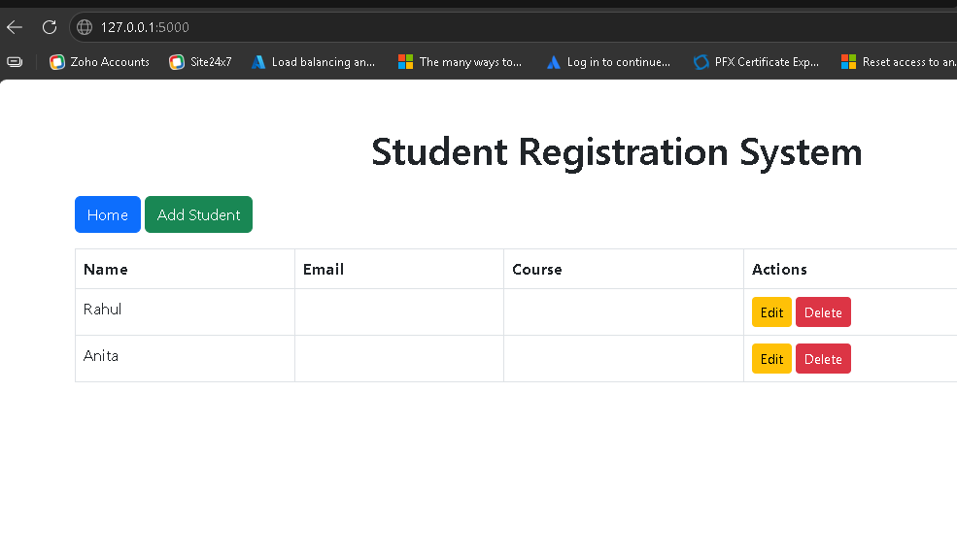Push the Flask Application repository to Github public repository.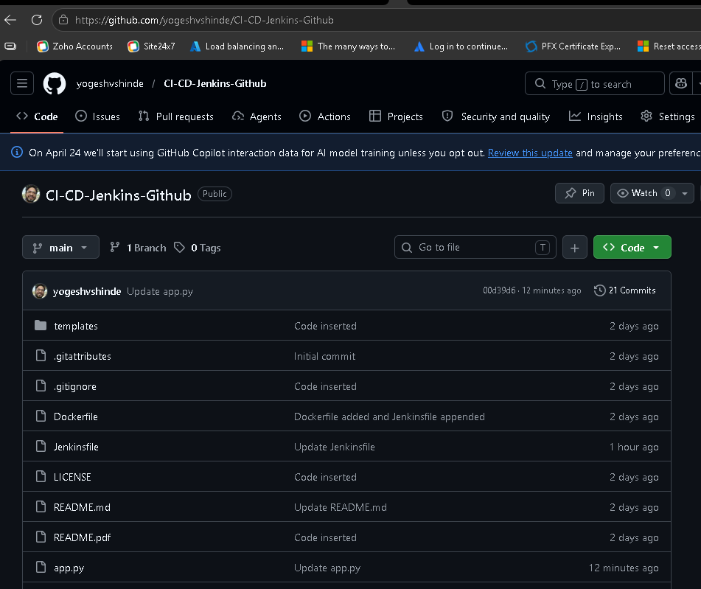

The approach will be to containerise mongo db and flask application to docker
Containers. The containers will be connected to each other in the same custom network named mynet.
Hence, install docker on the ubuntu VM and create a network named mynet.

Create a mongo database docker image and build and run the container.

sudo apt install -y mongodb
sudo systemctl start mongodb
sudo systemctl enable mongodb
docker network create mynet

Command to create a network for flask app and connect mongodb to it is as below,
docker run -d --name mongodb --network mynet -p 27017:27017 mongo

We have to make sure that the user should have access to docker group and Jenkins group for communicating with each other.
Command : sudo usermod -aG docker yogesh

The command to connect the mongodb to flask application is as follows,
docker run -d --name flask-container --network mynet -p 5000:5000 -e MONGO_URI="mongodb://mongodb:27017/mydb" flask-app-image

Docker ps command output:

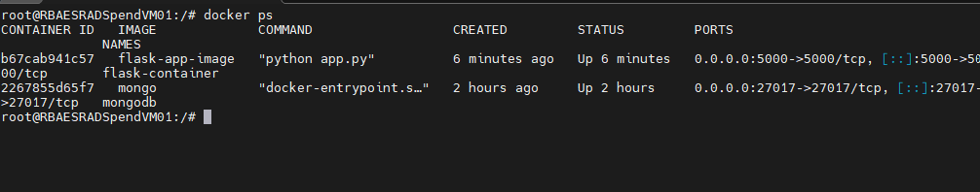

Install MongoDb and shell to create databases.

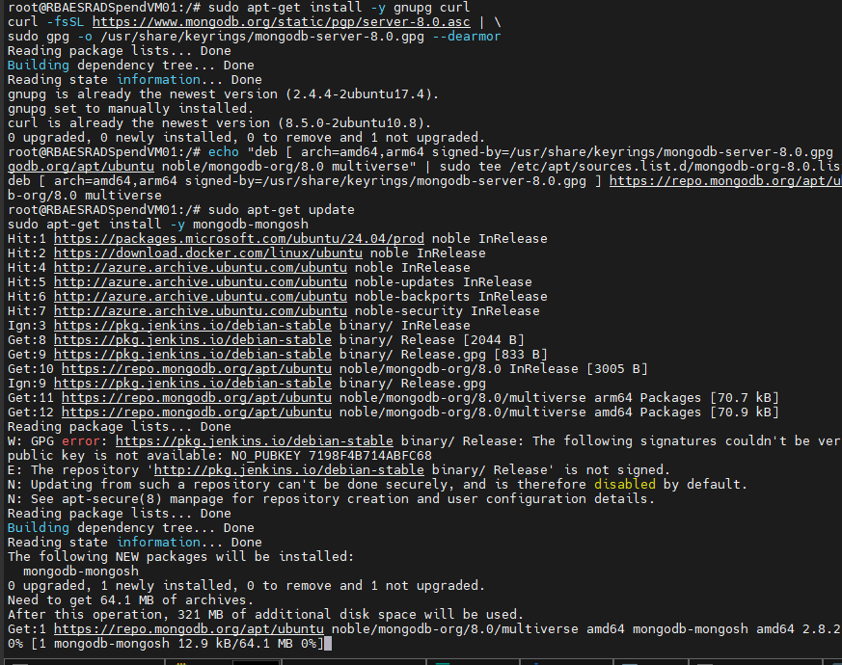

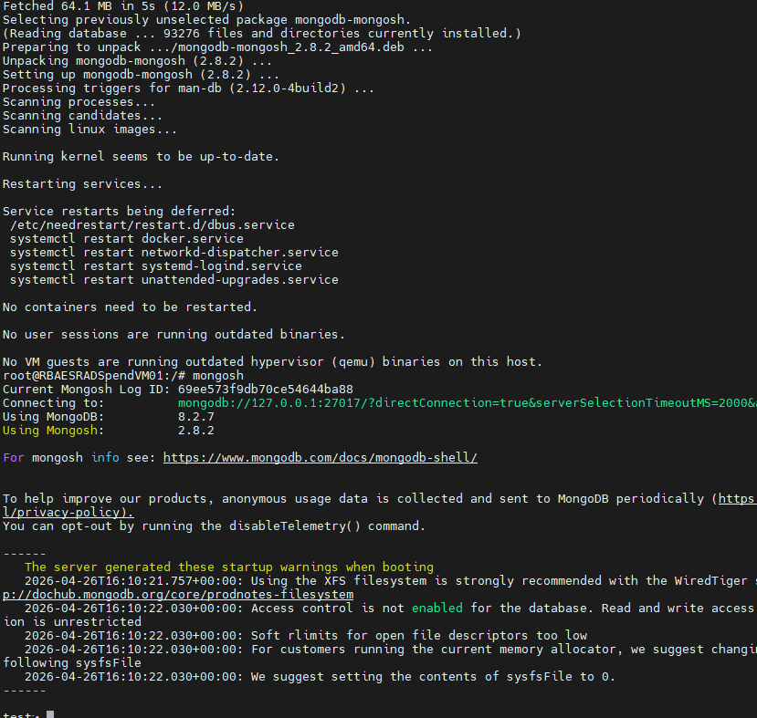
Create new database named mydb to store data,
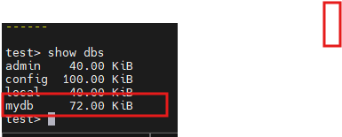

Show dbs

Prepare a Jenkins server on Ubuntu EC2 instance on AWS.

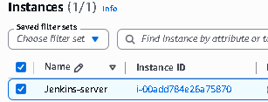

Access the Jenkins server using the public IP address

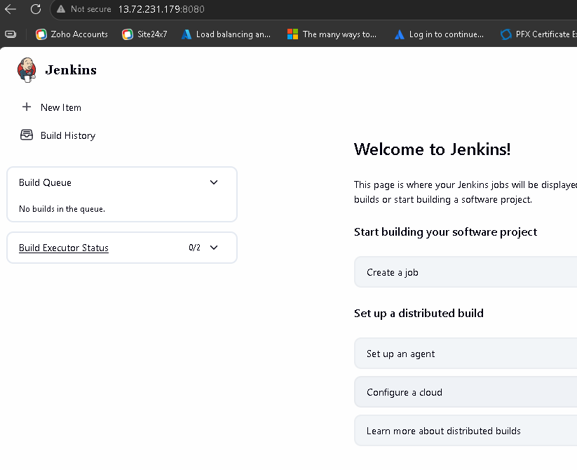

Install below Plugin on Jenkins server.

• Git Plugin
• Pipeline Plugin
• Email Extension Plugin
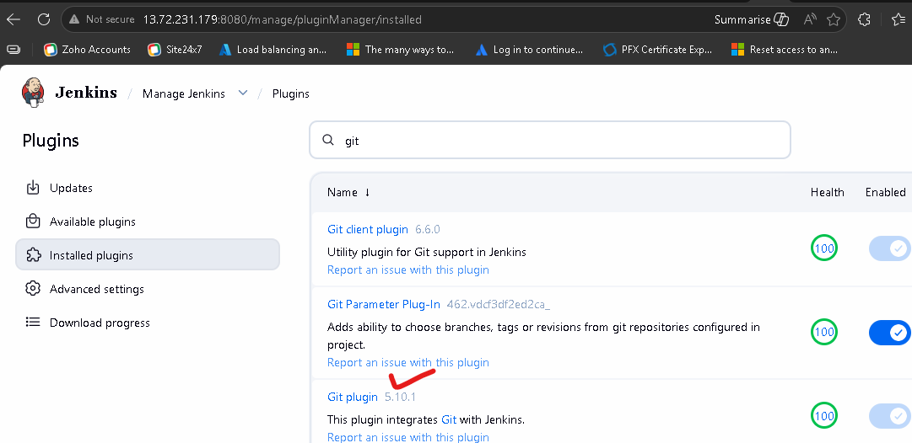

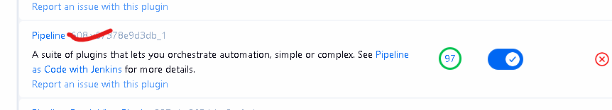

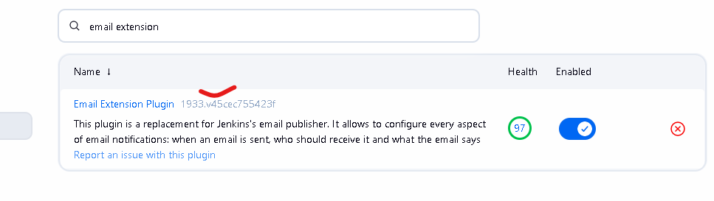
Created Jenkinsfile in the project folder on local and pushed it to Github repository,

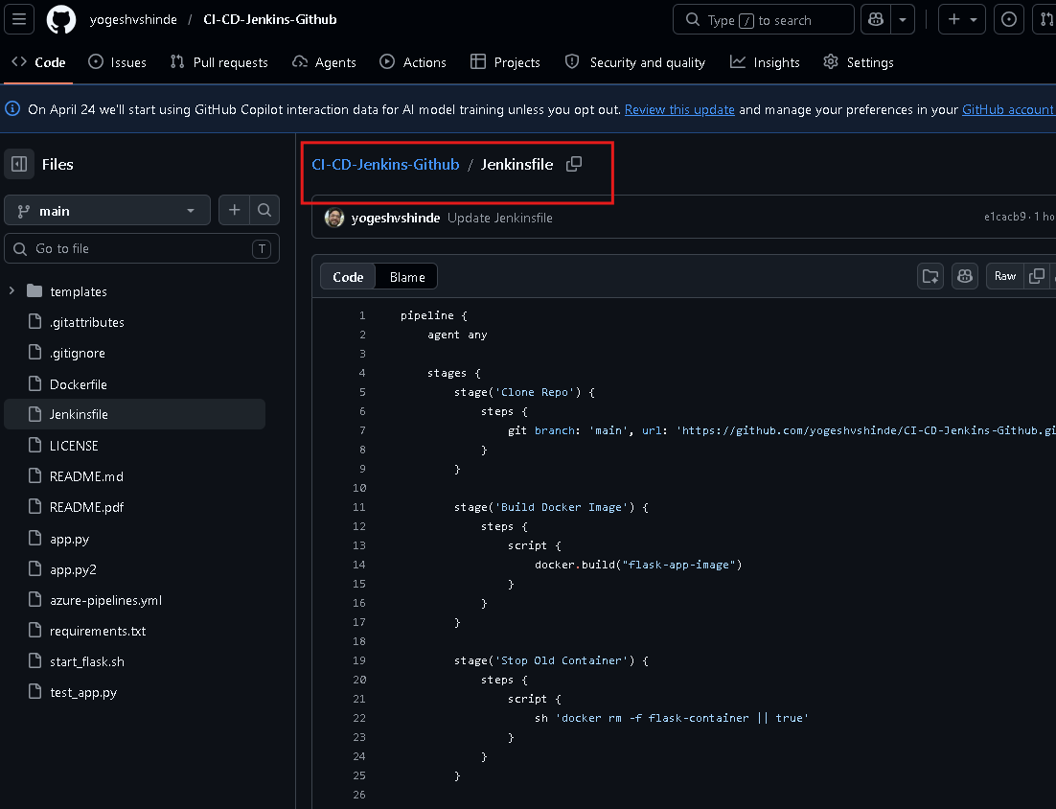
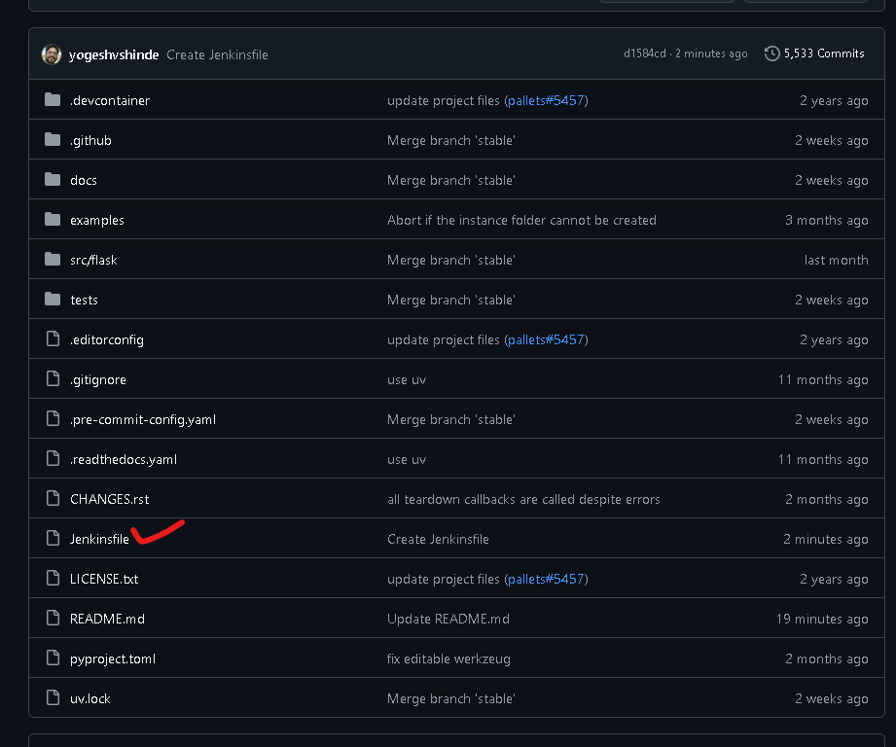

Setup Webhook (Trigger)

In GitHub:
Repo → Settings → Webhooks
Setup a webhook connection between Github and Jenkins server.
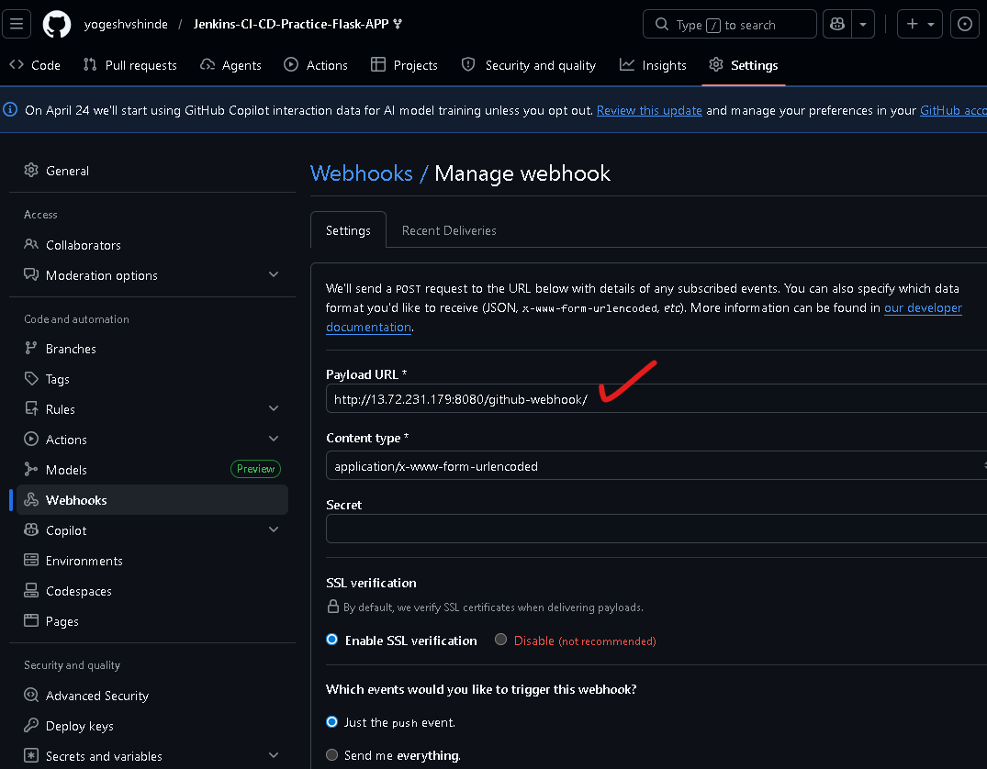

In Jenkins:

Create a new project named GitHub CI-CD Pipeline

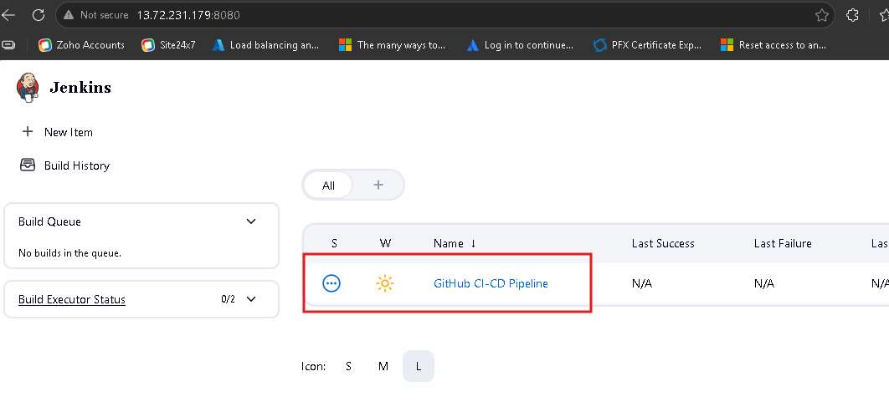

Enabled GitHub hook trigger for GITScm polling

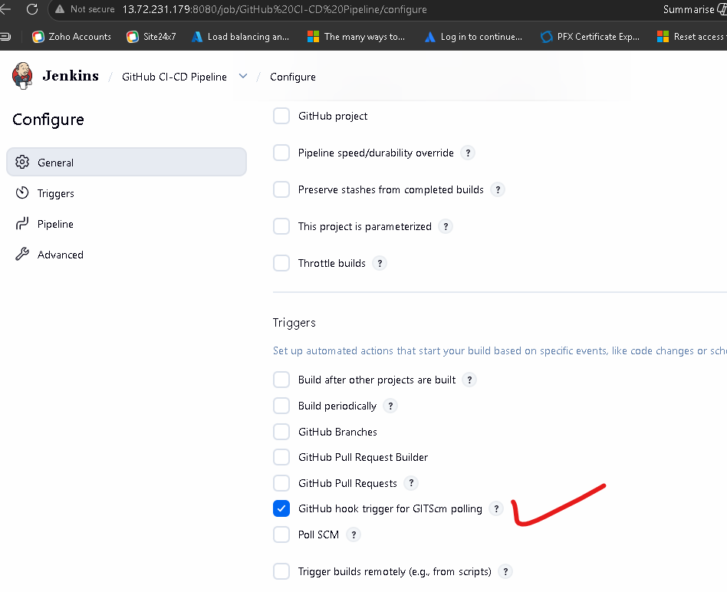
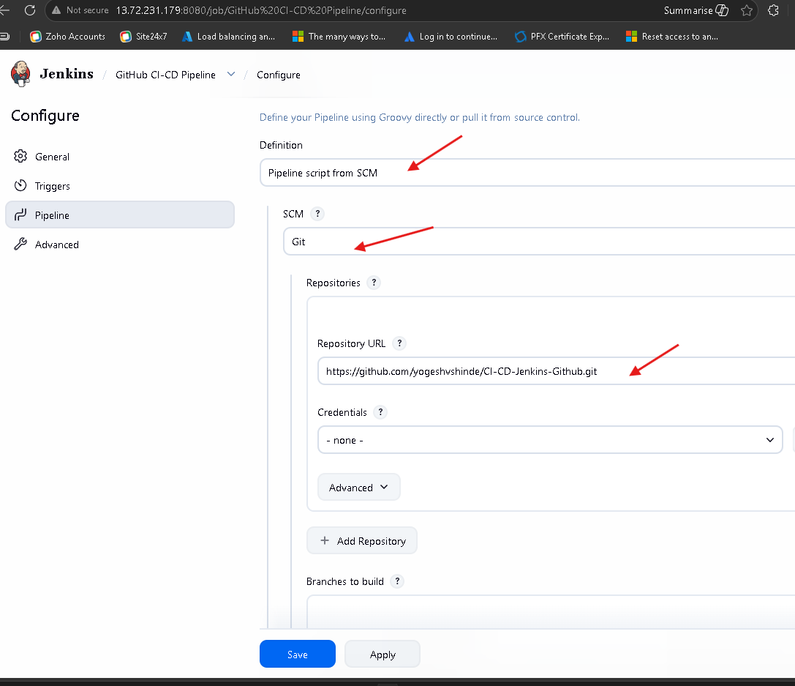

Setup Pipeline script to run from SCM using a Github Webhook and the Jenkinsfile will reside on Github Repository.

Enable Email Notifications
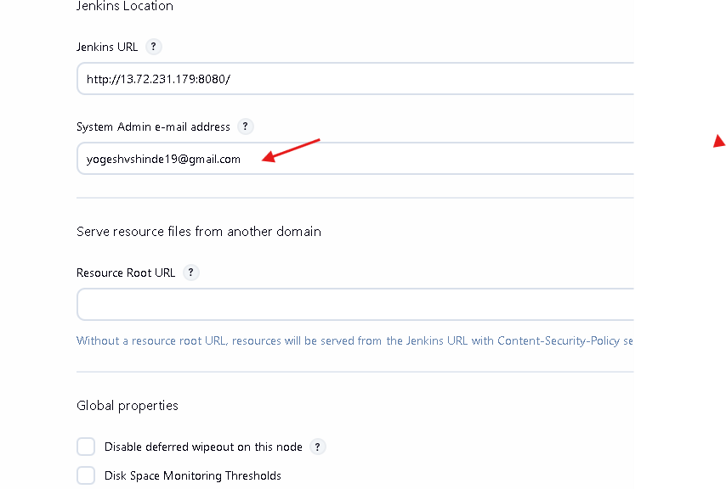

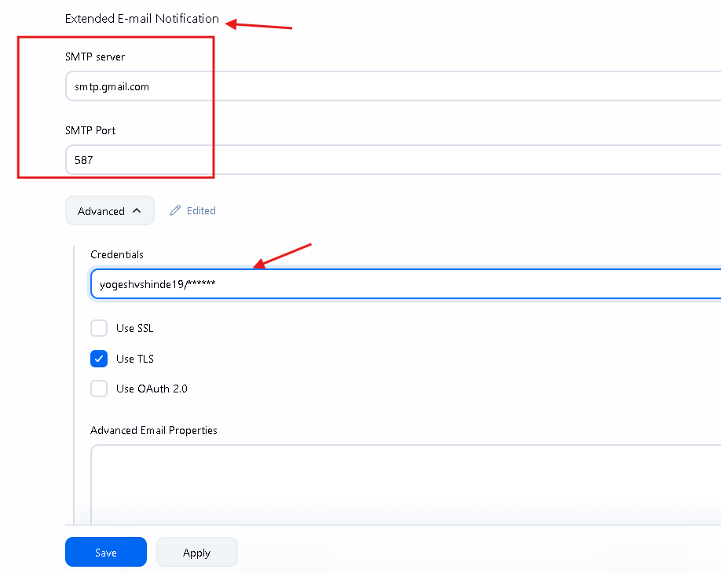
Now push the code changes to Github from local machine.
The GitHub webhool should now run and show deliveries in the webhools section.

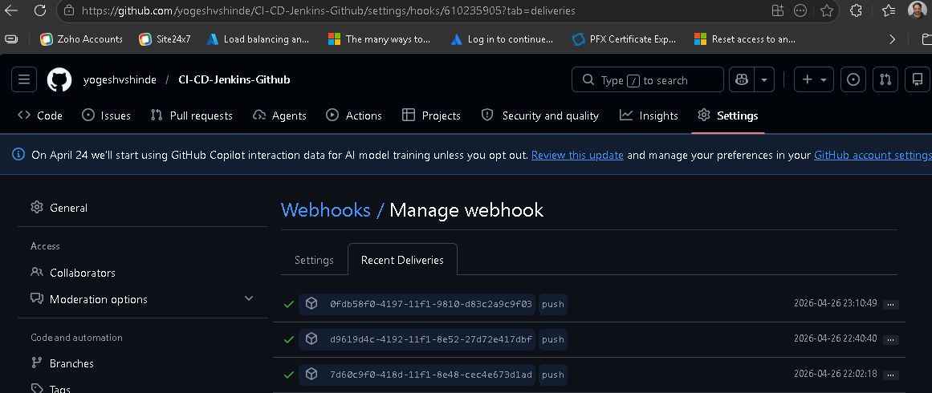

The Jenkins Pipeline will be auto triggered and will deploy the application to ubuntu VM.

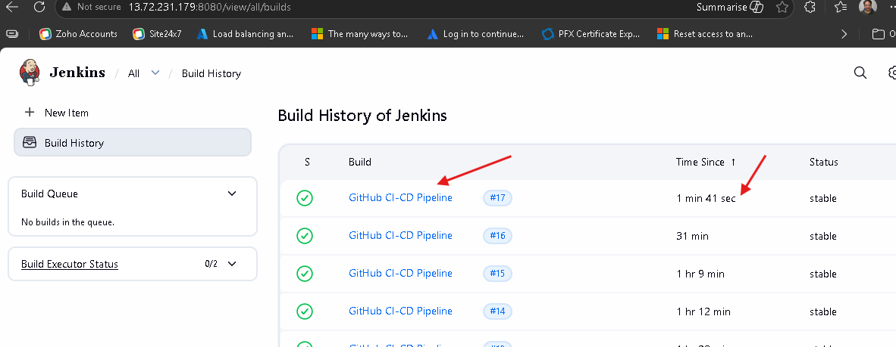

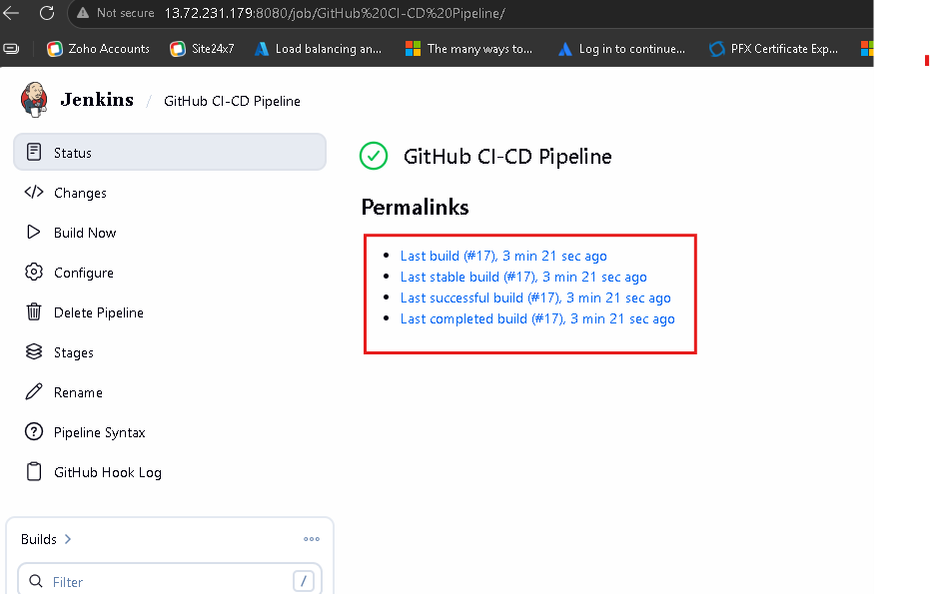

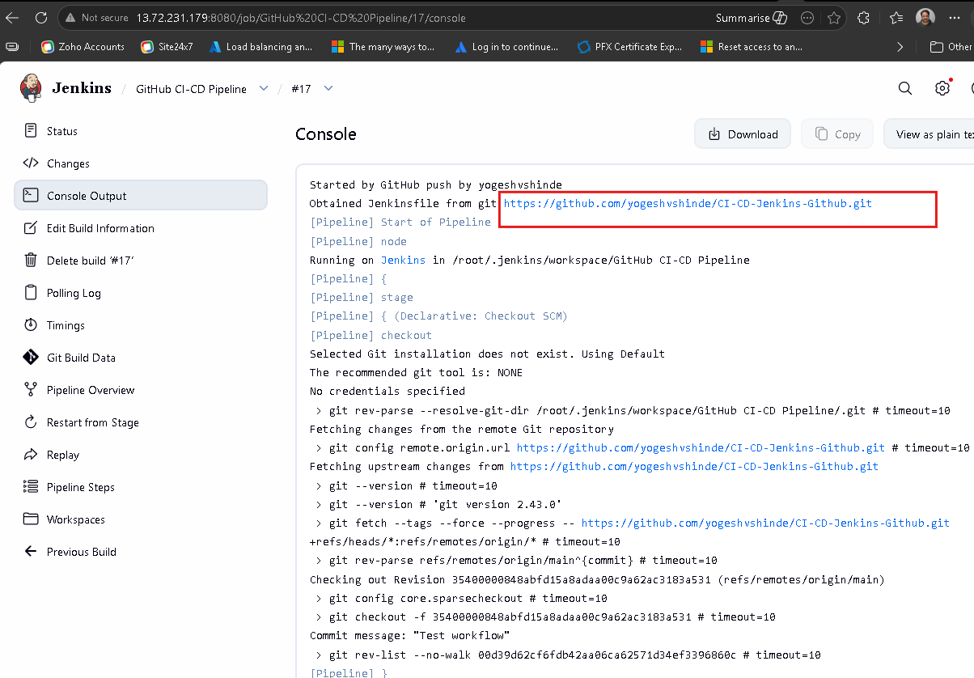

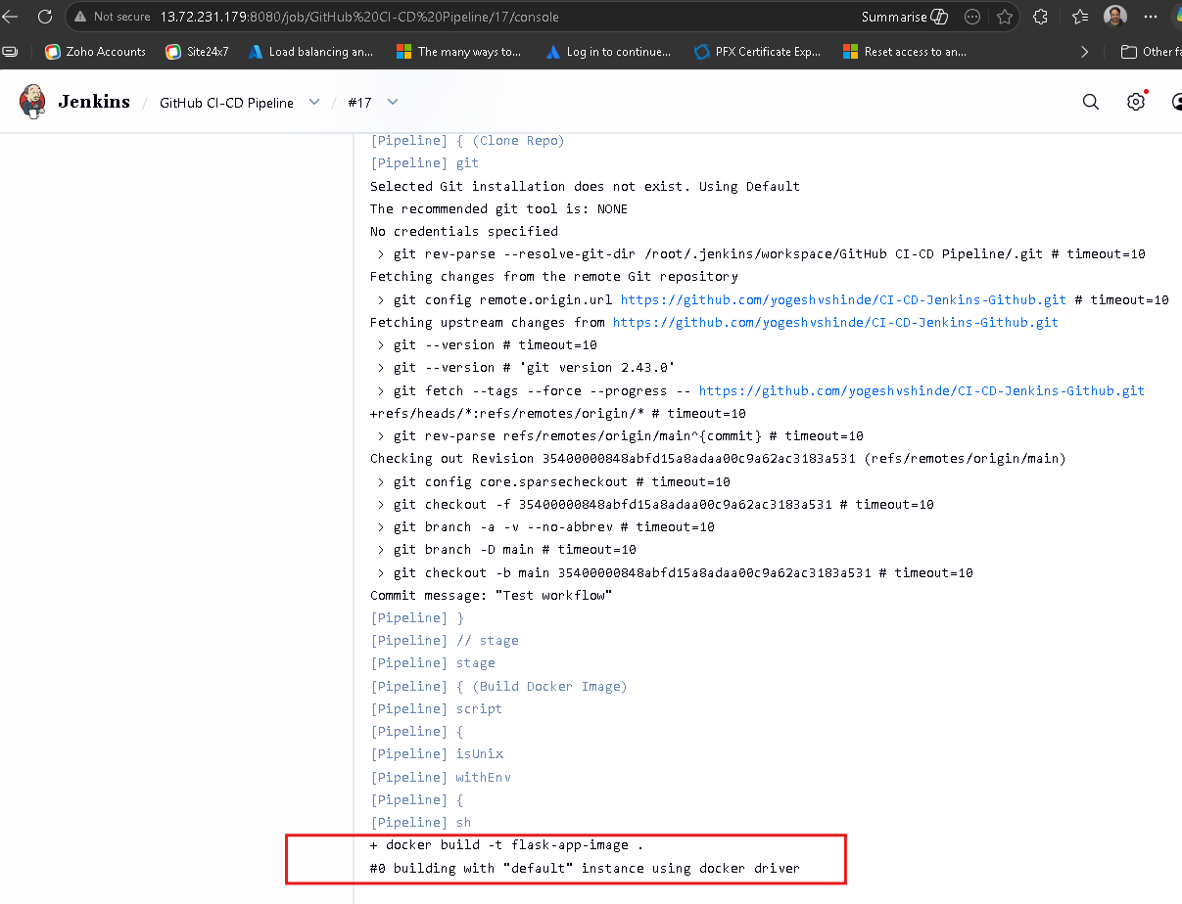

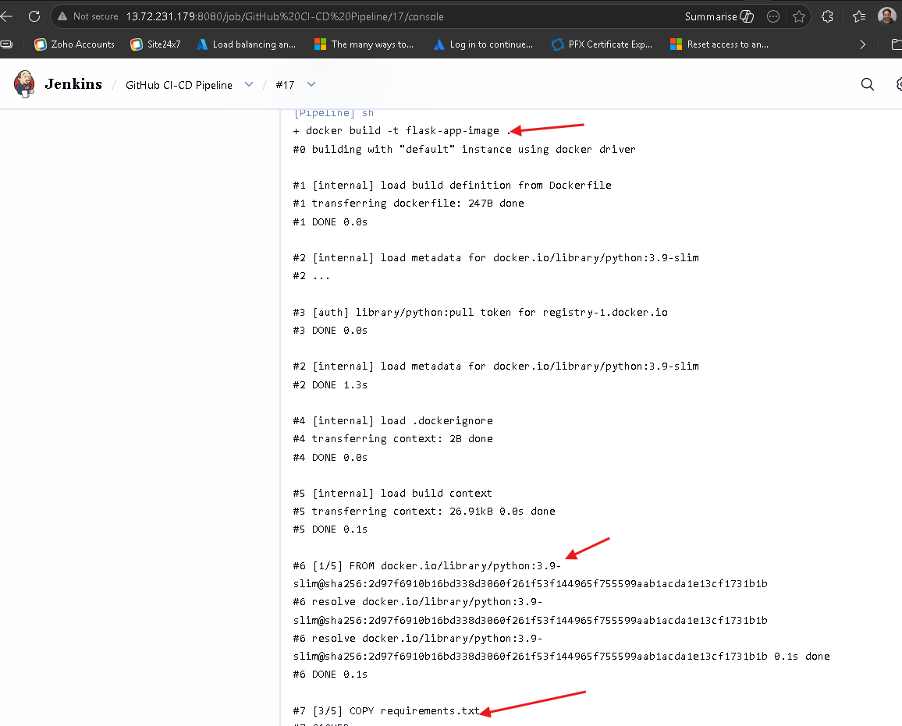

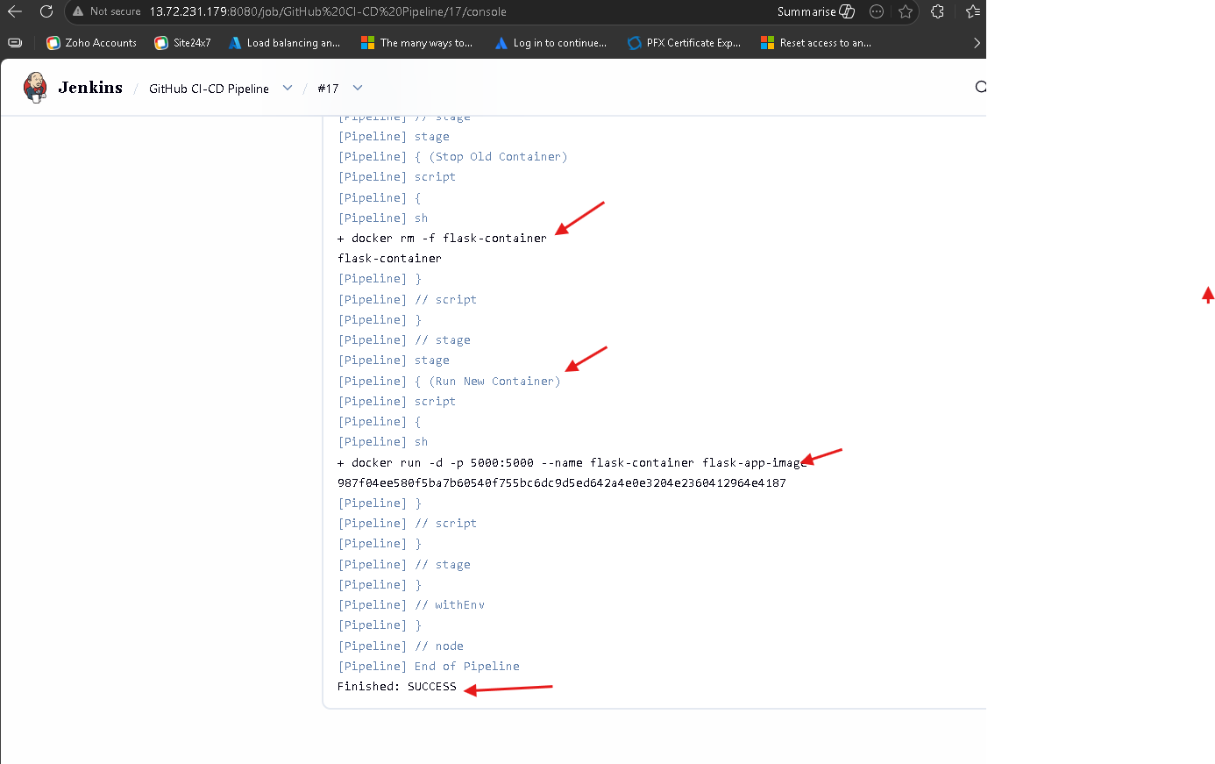

Now run the Flask application using the public IP with port number 5000

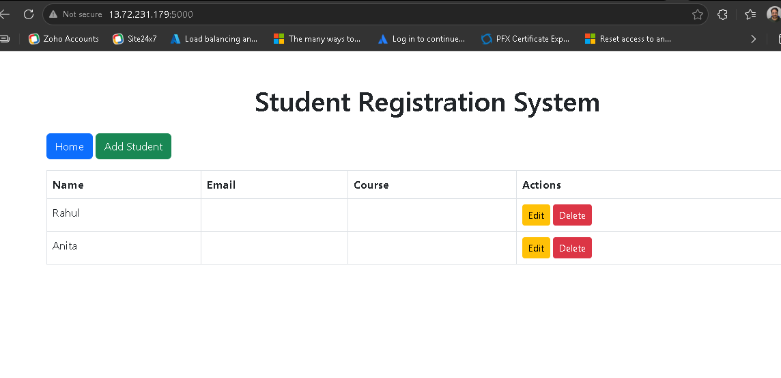

Add student and check if student entries can be saved in Mongo Database.

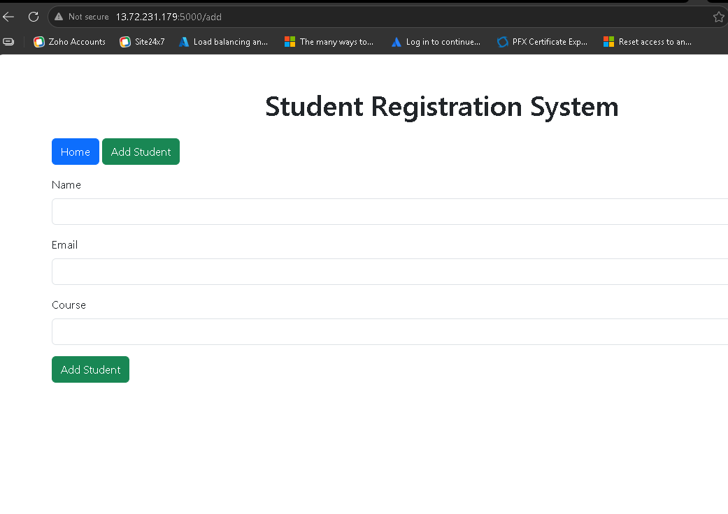
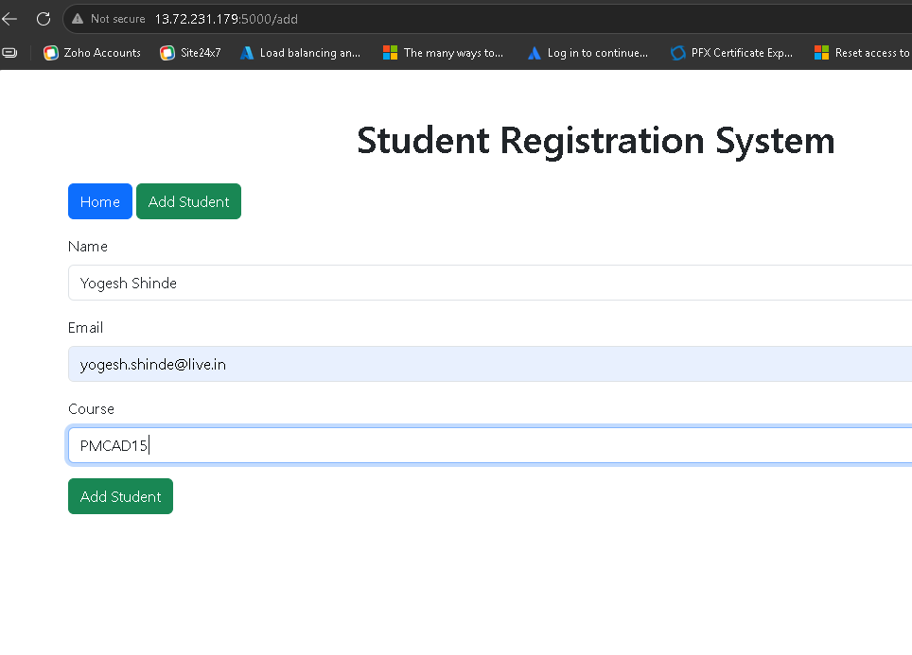

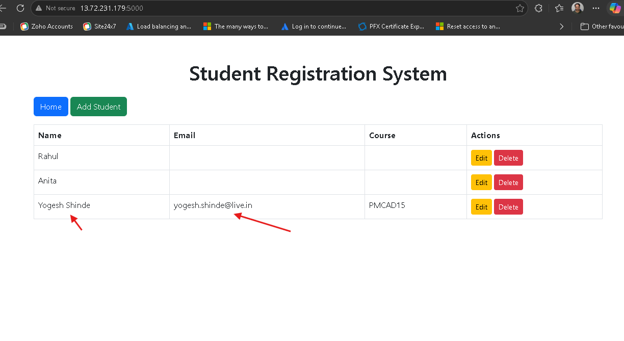

Student Entry added successfully. Hence, connection to database was successful.

Email notification sent successfully,
